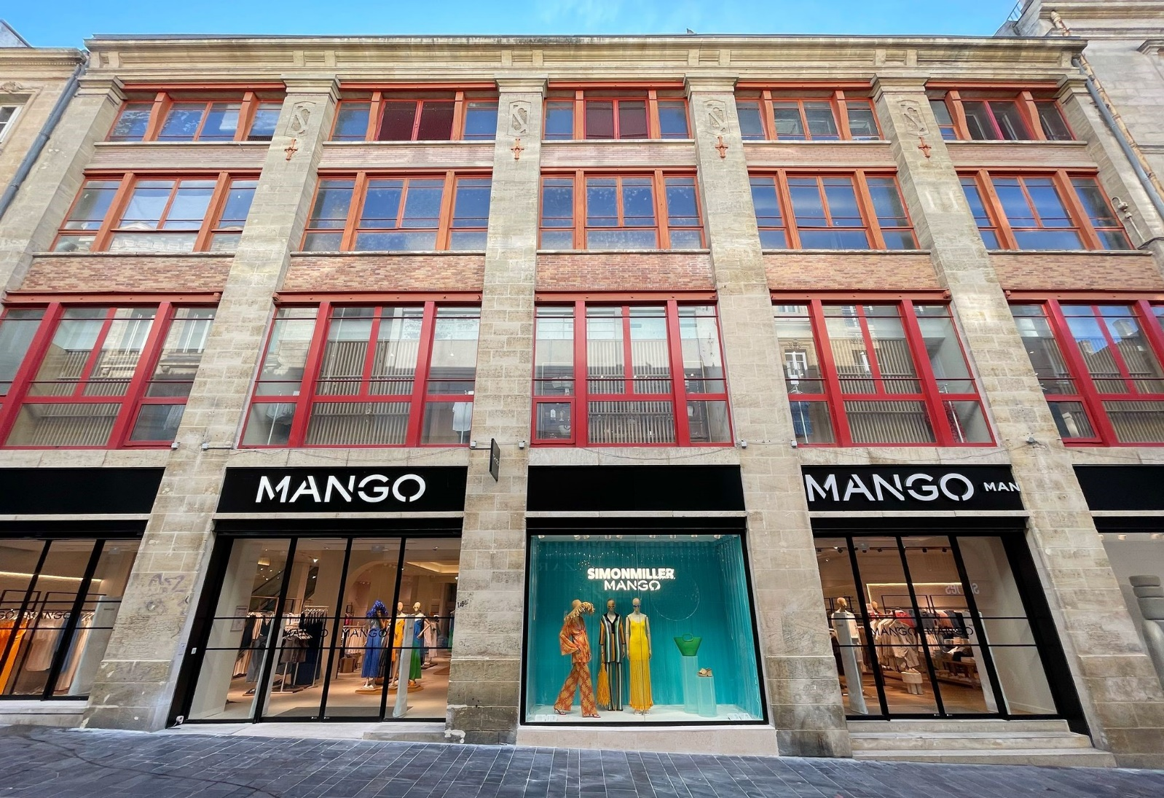
Mango takes its New Med store concept to Bordeaux with the refurbishment of its flagship store

- Today the company is reopening its store in Rue St Catherine, the longest pedestrianised shopping street in Europe, making it the first in the city to feature the New Med image.
- The store, which has a selling space of 950m² and stocks the Woman, Man and Kids lines, has renewed its fitting room zone to include adjustable lighting and has added new technologies and services to improve the customer shopping experience.
- The refurbishment is part of the plan to refurbish the Mango store network, which aims to extend this retail concept in stores, and to expand and consolidate the brand in France, one of its key strategic markets.
- Mango closed 2022 with 233 stores in France and an online presence through its e-commerce and marketplaces.

BARCELONA,
2 JUNE 2023
Mango, one of Europe’s leading fashion groups, is continuing with its plan to expand internationally and consolidate its brand in France with the reopening of its flagship store in Bordeaux. After four months of refurbishment, the store located at 24-30 Rue St Catherine, the longest pedestrianised shopping street in Europe and the most important in the city, reopens today.

The store, which has a selling space of more than 900 m² and stocks the Woman, Man and Kids lines, is located in a listed building in the centre of Bordeaux. With the refurbishment, the store has become the first in Bordeaux to feature the Mediterranean-inspired store concept, New Med, already present in some of the group’s flagship stores around the world, such as the Haussmann store in Paris.

The Mango New Med image aims to reflect the spirit and freshness of the brand and is strongly influenced by Mediterranean culture and lifestyle. Sustainability and architectural integration are key to this new design, which is why new stores feature elements such as eco-efficient lighting and heating and ventilation, and a design which incorporates sustainable materials such as natural paint.

With the store refurbishment, Mango has created a new fitting room area, increasing its size to make them more functional, while equipping them with adjustable lights. New technologies and services have also been added to improve the customer shopping experience, such as a specific click and collect zone for the collection and return of orders; a container where customers can deposit used clothing and footwear to give their garments a second life; and RFID technology for better stock control. In the coming months, a skylight on the first floor will be recovered, allowing the entry of more natural light.

The refurbishment is part of the plan to refurbish Mango stores, which aims to extend this new retail concept in its stores. It also allows the company to expand and consolidate its brand in France, one of its key strategic markets.

Mango has been present in France since 1998. The company closed 2022 with 233 stores in the country, including company-owned stores, franchises and corners in department stores. The company also has an online presence via its own online channel and other marketplaces.

For more information, please contact:
Miki Herráiz
+34 610 449 839
miguel.angel@mango.com

Mango, one of Europe’s leading fashion groups, is a global company with design, creativity and technology at the centre of its business model, and a strategy based on constant innovation, the search for sustainability and a complete ecosystem of channels and partners. Founded in Barcelona in 1984, the company closed 2022 with a turnover of 2.688 billion euros, with 36% of its business originating from its online channel and with a presence in over 115 markets. More information at mangofashiongroup.com

